Simulation and reflectivity measurements of the ITER first plasma beam dump material
Andreas Hentrich¹
¹University of Stuttgart, Institute of Interfacial Process Engineering and Plasma Technology, Germany
Abstract. When constructing a beam dump for a fusion device, one faces several challenges and constrictions: It must be vacuum compatible, resistant to temperatures and radiation, should neither gas out nor deteriorate, should take up as less space as possible and obviously also should absorb microwave radiation well. As possible candidates, the group of ceramic metal oxide layers have been suggested, from which three different material systems have been produced by atmospheric plasma spraying and investigated: Titanium oxide, chromium oxide and an aluminum-titanium oxide compound material. Both pure titanium oxide and chromium oxide don't show the absorption necessary, but Al₂O₃/TiO₂ (60/40) is very promising and will be presented in the following.

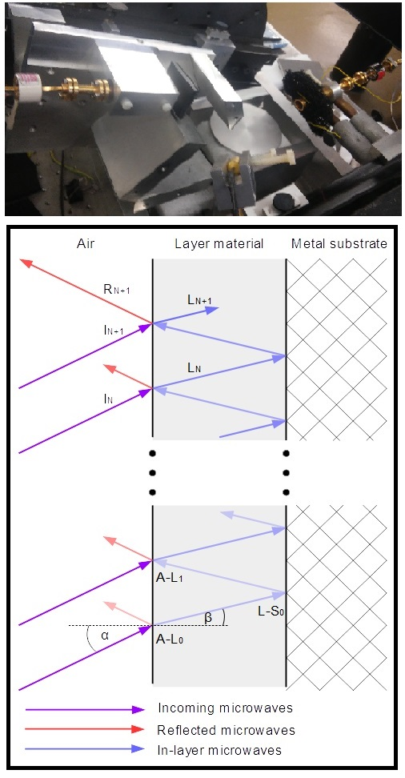
- Sample, measurement & model description
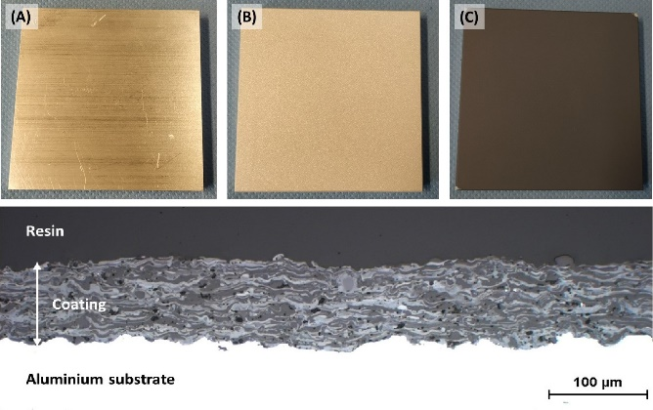
The samples were produced and characterized regarding thickness and surface roughness by Venancio Garcia at the IFKB stuttgart, the production process and a cross section in shown in figure 1. The thickness of the samples could be reliably determined upto ±5µm by the production process. In total, 11 samples with thicknesses between 30 and 180µm have been produced and investigated.
Fig. 1. (A) substrate, (B) after grit blasting, (C) after plasma spraying, (D) cross-section
Afterwards, the reflectivity of the samples was measured. For this, a network analyzer was used to generate the microwave and the local oscillator. To get the intended measurement frequency of 170GHz, a harmonic generator was used and with the help of an harmonic mixer and the LO, the signal was modulated back down to a measurable frequency. For emitting the microwave onto the sample and receiving the reflection of it, two optimized horn antennas were used.
Fig. 2. The measurement setup and a sketch of the model
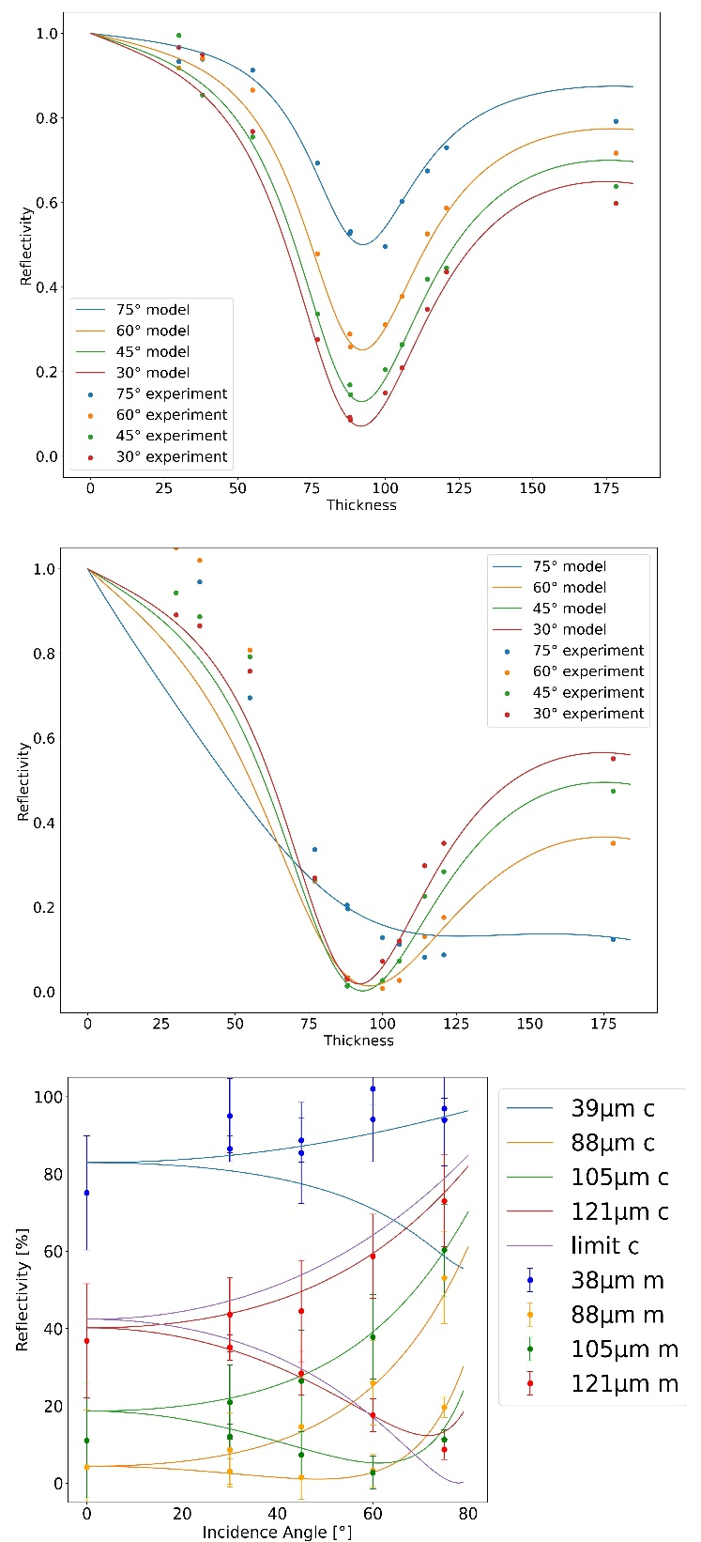
As reference an aluminum mirror was used. The dependency of the reflectivity on layer thickness, polarization and incidence angle was measured.
In parallel, a plane wave model was developed to describe the situation at hand from a theoretical point of view. It neither uses the approximation of low nor high absorbing materials and considers the existence of multiple reflections, but is limited to a single frequency and assumes smooth surfaces everywhere. The substrate is simply treated as perfect electric conductor compared to the layer material. The relevant parameters of the model are: frequency and polarization of the wave, incidence angle and layer thickness for the geometry and refractive index and absorption coefficient as material parameters. Both the wave and the geometry parameters are known in advance either by setup and/or previous measurement, just the material parameters are undetermined and were thereby aquired by fitting, for further details of the model or to the fitting refer to [1].
- Experimental findings
Measurement and simulation have been found to be in reasonable agreement, the refractive index was determined to be 4.734 and the absorption coefficient A_{Layer}= ω * ε'' + σ to be 93.3 S/m (equal to s³A²/(m³kg)), which is comparable to literature values for similar materials at 140GHz [2]. The peak of absorption lies at 90µm and depending on incidence angle and polarization, between 50 and more than 90% of the incoming microwaves were absorbed.
Through the model, the reason of the advantageous absorption properties compared to the other two materials could be determined: Surprisingly, the compound material does not absorb better, because it has a higher absorption coefficient than the other materials, but exactly the opposite of it. This leads to an increased resonator effect, whereby the microwave travels for a much longer time inside the layer, by far offsetting the decreased absorption per length unit.
The second important effect measured is, that the resonant thickness is almost independent of the incidence angle. Normally one would expect by geometry, that a higher incidence angle leads to a bigger phase shift, when passing through the layer, compared to a lower incidence angle for the same layer thickness. Thereby it is reasonable to assume, that higher incidence angles have smaller resonant thicknesses. This effect could be firmly rejected for the investigated material and again the reasons could be concluded from the model: At first, the refractive index of the material is comparably high, thereby decreasing the difference in angle for the diffracted wave inside the medium of an high incidence angle wave compared to a low incidence angle one. Secondly, for higher incidence, the wave not just travels longer inside the material, but also longer inside the air before interfering with itself, whereby the two phase shifts partially cancel out. This has positive implications considering the possible use to absorb stray radiation or when the geometry of the situation changes, because the optimal layer thickness will stay (almost) constant.

Fig. 3. Thickness dependency of the reflectivity for orthogonal and parallel polarization respectively, additionally the incidence angle dependency. The points are the measured values, the lines the respective calculated ones.
- Simulation results
The model further allows to enhance the understanding of resonant absorbers. In figure 4 the reflectivity as function of thickness at increasing absorption is shown.
As expected, when the absorption coefficient is very low, the microwave won't be disturbed by the layer and is simply refllected at the metal substrate. The exception is the resonant thickness at around 90µm, at
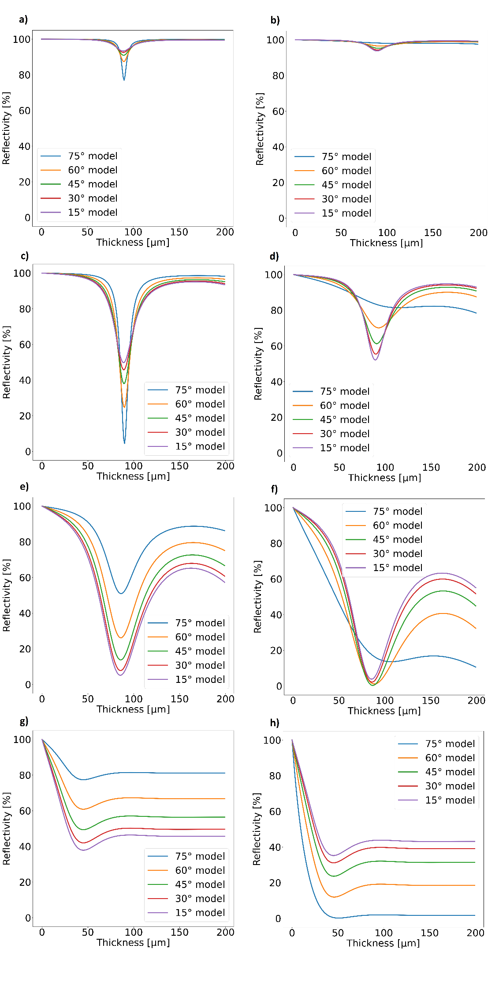

Fig. 4. Modeled data for the result of a change in absorption coefficient on the thickness dependency with a refractive index of 5. Left column is orthogonal, right one parallel polarization, the absorption coefficient from top to bottom is 1, 10, 100, 1000.
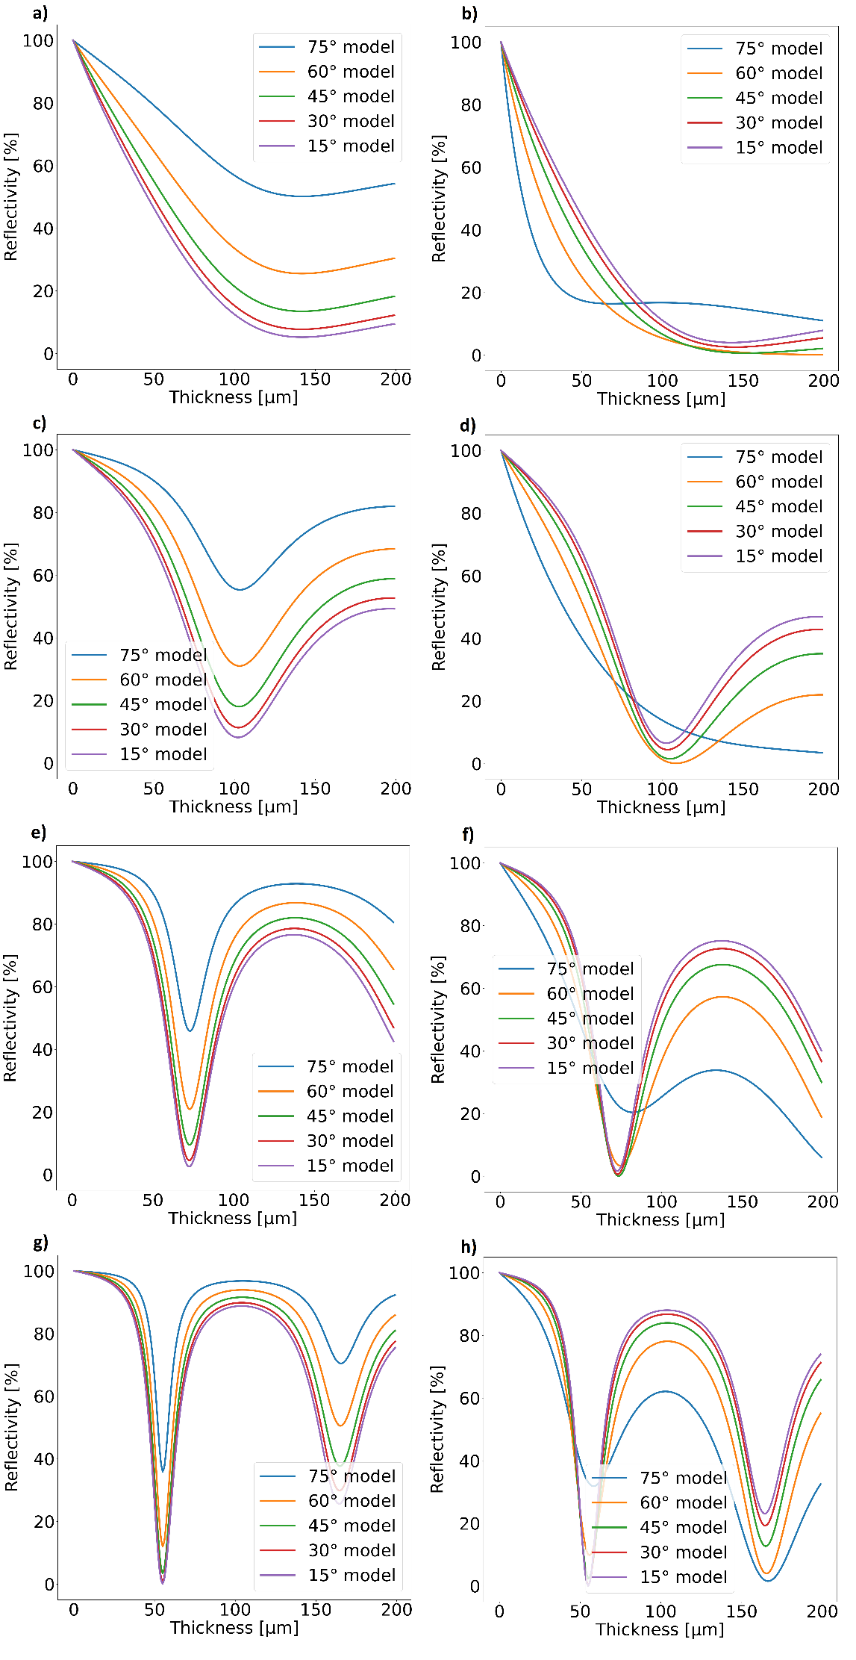

Fig. 5. Modeled data for the result of a change in refractive index on the thickness dependency with an absorption coefficient of 100. Left column is orthogonal, right one parallel polarization, the absorption coefficient from top to bottom is 2,4,6,8.
which the phase shift induced by the passage through the layer exactly leads to destructive interference at the layer to air interface. Thereby the microwave travels for much longer distances inside the layer, whereby even with small absorption per distance an effect is visible.
When increasing the absorption coefficient (c and d), the absorption at the resonant thickness will increase dramatically, especially for the orthogonal polarization. At the same time, the absorption for a microwave, which travels just once through the layer, is still negligible. At this point the resonantor properties are absolutely dominant.
Increasing it even further (e and f), to a level comparable to the measured material, the effects become more complicated, because now two contributions are overlapping for the reflectivity: At first, the resonator effect is still very relevant, the resonant thickness is clearly visible. In contrast to before, even at not resonant thicknesses relevant absorption occurs. This means that even after a single passing a relevant amount of energy is absorbed, whereby the destructive interference and thereby the resonator is perturbed. This increases the effect of the first time the wave hits the air-layer interface.
For very high absorption coefficients (g and h), the dependency simplifies a lot: Now practically the complete energy, which passes into the layer is absorbed in the course of the first passing through the layer. This means no destructive interference can occur, the only relevant factor left is, what the reflection coefficient is at the first air-layer interface. Also, this results in the value of the thickness being mostly irrelevant, the whole energy traveling into the layer will be absorbed either way. This complete surpression of the resonator effect leads to the curious effect described before, that a material with such a high absorption coefficient is actually a worse absorber than a resonant layer with a lower one.
Another effect, which can be seen, is that the increase of absorption coefficient will shift the resonant thickness. This is due to the fact, that for materials with significant absorption the effect of the absorption on the wavelength can not be neglected anymore [3], whereby the wave length decreases and logically the phase shift per length traveled in the material increases, leading to a lowering of the resonant thickness.

Additionally one can estimate the effects of the refractive index on the absorption properties (figure 5). When starting with low refractive indices (a and b), the absorption peak around the resonant frequency is excessively broad and it is generally speaking a very good absorber. One of the reasons is, that the small difference in refractive index at the air-layer interface leads to a very small initial reflection. The second reason is, that a smaller refractive index for the same absorption coefficient leads to a larger attenuation constant [1]. What needs to be taken care of: The effect described before, that the resonant thickness is mostly independent from the incident angle, is definitely not the case for these kind of materials, which is also expected, considering the surpression mechanism described before.
Increasing the refractive index (c and d) will lead to a decrease of the effective absorption and more reflection at the initial air-layer interface, thereby decreasing the absorption drastically at most thicknesses. The obvious exception is the resonant thickness, which now shifted for obvious reasons to lower values, but interestingly has very similar absorption properties than before. The effects of a decreasing effective absorption coefficient and an increase of passages through the layer cancel out almost perfectly.
With the next increase (e and f), the absorption under non-resonant conditions becomes very small. Additionally the absorption peak becomes increasingly sharp, while the absorption values are still similar to before. With these sudden shifts in reflectivity it also becomes increasingly hard to produce a layer at the resonant thickness, because within the expected thickness error of the plasma spraying of ±10µm the reflectivity already changes significantly.
Finally, with a refractive index of 8 (g and h), a second absorption peak shows up in the displayed thickness region. The trends from before simply continue: Sharper resonance peak, less absorption outside the resonance, but almost identical to the one before directly at the resonant thickness. A small, but interesting effect is also visible when comparing the two polarizations in (g) and (h): While in the orthogonal case, the 75° incident angle is the worst absorbing case for both visible absorption thicknesses, it's actually the best absorbing one for the second peak of the parallel polarization. The origin of this lies in the dominant contribution. In both polarizations the resonator contribution is dominant for the first peak and high incidence angles lead to a worse resonator, thereby decreasing the absorption. For the second peak, the wave needs to pass through three times the thickness, whereby a higher percentage of the microwave is absorbed, which in return leads to a less dominant resonator contribution and an increased importance of the initial reflection at the air-layer interface. And when investigating this contribution (the large thicknesses at figure 5 g and h), it becomes clear, that high incidence angles for parallel polarization absorb the best and high incidence angles for orthogonal polarization the worst.

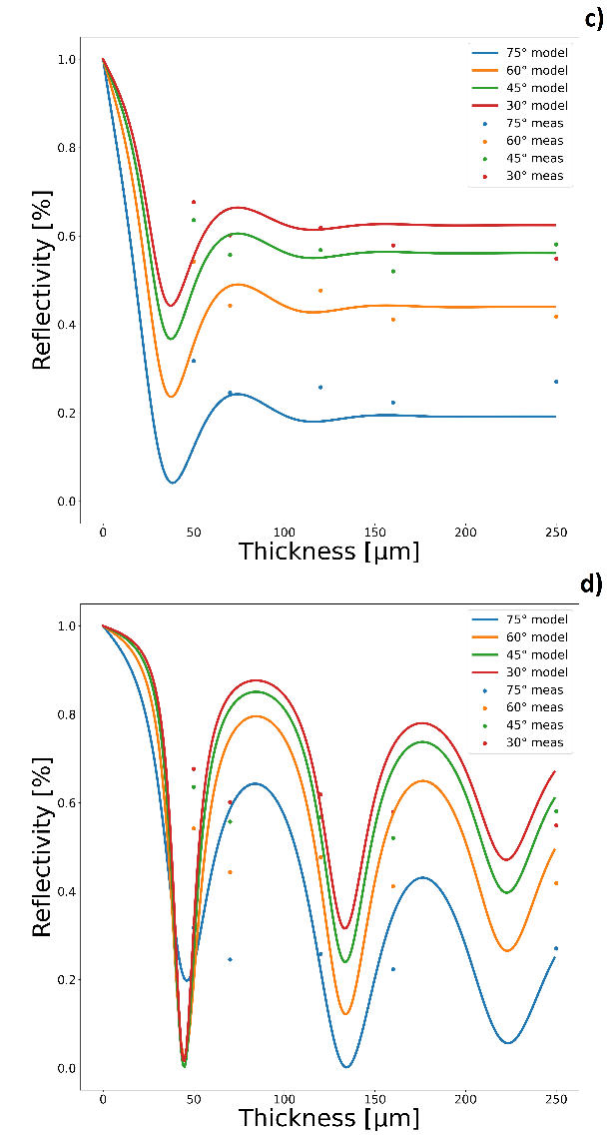
- Summary and future research
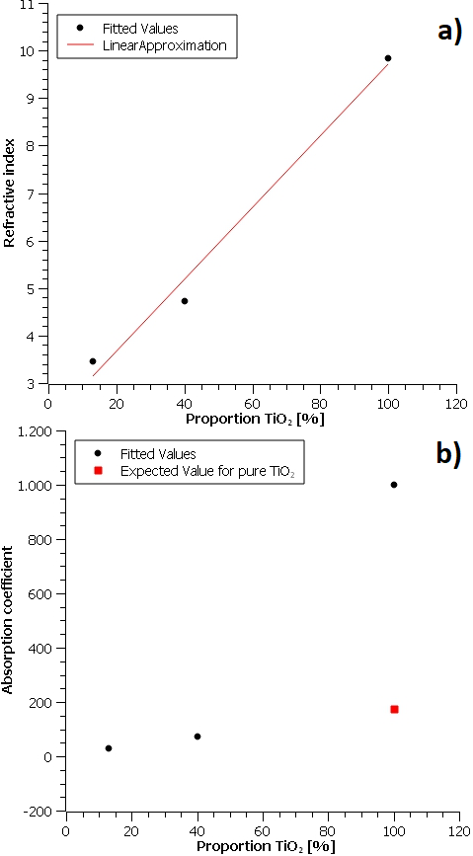
The current state of work has been presented. This included a short presentation on the production process, the measurement and the theory side of oxide layer materials used for microwave absorption. Because these have been described excessively in previous work [1], a focus was on the simulation. These were done using a plane wave model, which takes into consideration the not purely dielectric nature of the materials and multiple reflexions. It has been shown, that measurement and simulation are in reasonable agreement, so the model was now used to predict some of the behaviour of these kind of materials. The main results were: A resonance occurs when the thickness of the layer results in a phase change in a single passage equal to π/2, which can be used for efficient absorption, this thickness is for 170GHz in the order of magnitude of 100µm. There exists an optimal absorption coefficient, both below and above this value the effective absorption is reduced, for a frequency of 170GHz the value is usually between 50 and 500S/m, depending on the refractive index. Speaking of refractive index, in general one below 6 is favourable, otherwise the absorption peaks become so narrow, that the samples are difficult to produce with an exact enough thickness. At the same time, a refractive index above 4 has the advantage, that the angular dependency of the resonant thickness is greatly surpressed, which makes the absorption mechanism also interesting for situations with unknown incidence angles.
The next step is to find a way to change the material parameters in the production process by altering the percentage of titanium oxide in the compound material, Fig. 6. The effect of an increase in TiO₂ proportion on the refractive index (a) and absorption coefficient (b). In red the linear fit and the expected value from a linear fit respectively is shown. In (c) and (d), the resulting thickness dependency for pure TiO₂ is shown, when considering an absorption coefficient of 1000S/m (c) and one of 175S/m (d).
which would allow the production of beam dumps by design. This process is already in progress, till now three material systems have been investigated: pure titanium oxide, the presented 40% one and a 13% one, with the rest being aluminum oxide. From microscopic images (compare figure 1) it is known, that the two oxides mostly stay in separate phases, a large change in atomic structure is therefore not expected. Also we can assume, that compared to the 1.76mm wavelength of the microwave, the materials are almost homogeneous, thereby a linear change of the material parameters is at least a reasonable first expectation.
When investigating the refractive index dependency (figure 6a), a linear dependency seems to be confirmed. In contrast, when looking at the absorption coefficient (figure 6b), the expected value from a linear extrapolation for pure TiO₂ is just a fifth of the value estimated by the optimized parameters, which come from fitting the model to the measurements. This leads to two possible conclusions: The linear dependency is simply not correct for the absorption coefficient or something with the optimization went wrong. A closer look into the thickness dependency of pure TiO2 makes the second option more likely: In 6c the fit is displayed, when using the optimized absorption coefficient of around 1000 S/m. There is a reasonable agreement with the measurement points. The problem is, when using the 175S/m instead coming from the linear extrapolation, it is also not completely unreasonable. This showcases a fundamental problem: With the high expected refractive index of TiO₂, three absorption peaks can be expected in this thickness range. The five measured thicknesses are simply a too low resolution to describe the three absorption peaks sufficiently, leading to inconclusive results for this material. The obvious conclusion is: more research is necessary, especially more thicknesses for titanium oxide to determine the material parameters accurately and in general more material compositions, to evaluate if the linear dependency hold true.
The biggest shortcoming of this study so far is, that all measurements and experiments were performed at standard conditions, so at room temperature and not at the upto 500°C, which is expected in the later device for the beam dump. This is far from ideal, thereby making temperature dependency plus stability of the material the obvious next focus of research. Additionally in the scope of the approval process of the material for ITER, the vacuum compatibility needs to be proven.

References
- A.Hentrich et al., Resonant Atmospheric Plasma-Sprayed Ceramic Layers Effectively absorb Microwaves at 170 GHz, J Infrared Millim Terahertz Waves (2022)
- R. Wacker, F. Leuterer, D. Wagner, H. Hailer, W. Kasparek, Characterization of absorber materials for high-power millimetre waves, in Proceedings of the Conference: Infrared and Millimeter Waves (2002)
- Y.Duan and H.Guan, Microwave absorbing materials, Chapter 1, Pan Stanford Publishing Pte. Ltd., Singapore (2016)

Corresponding author: andreas.hentrich@igvp.uni-stuttgart.de

