Physics Studies for Assessment of Requirement of Displacement Compensation System for ITER ECE Diagnostic

S. Danani1*, Hitesh Kumar B. Pandya1,2, Pratik Vaghashiya1, Shrishail Padasalagi1, Ravinder Kumar1, W. L. Rowan3, J. P. Ziegel3, Vinay Kumar,1,2

1ITER-India, Institute for Plasma Research, Gandhinagar 382428, India

2Homi Bhabha National Institute (HBNI), Mumbai 400094, India

3Institute for Fusion Studies, The University of Texas at Austin, Austin, TX 78750, USA

Abstract: The Electron Cyclotron Emission (ECE) diagnostic has the key function of measuring the core electron temperature profile and electron temperature fluctuation, from the intensity of electron cyclotron radiation emitted from the plasma along the major radius. The ECE diagnostic consists of three main systems: (1) front-end optics, which collects the radiation from the plasma, (2) transmission lines including polarizer splitter unit, which transports the ordinary and extraordinary ECE emission modes separately from the front-end and distributes it to the instrumentation, and (3) detection and analysis instrumentation which is housed at a distance from the tokamak, in the diagnostics building [1]. With its high electron temperatures and harsh environment, ITER presents various challenges for the diagnostic system. One of the most insidious is the misalignment between the in-vessel front-end optics and the ex-vessel transmission line which is caused by vibration of the vacuum vessel during operational and baking phases. Since the electron temperature is inferred from the intensity of the ECE, transient misalignment may lead to poor accuracy in this critical measurement. These displacements are expected to be ~ 15 mm in vertical (z) and horizontal (x) directions, and ~ 5 mm in the toroidal (y) direction. It is important to minimize the effect of these displacements, so that the system maintains alignment during operation, and reliable temperature information is attained. Our objective is to first study the coupling losses due to imperfect coupling of Gaussian beams owing to port plug displacements. Measurements are done to determine the power loss due to coupling of offset beams experimentally. The measured value for coupling loss is ~2 dB at 120 GHz, which is quite high, and it is therefore concluded that a mechanism is needed to compensate for the displacements.

1 Introduction

The ECE diagnostic has the key function of measuring the electron temperature profile and electron temperature fluctuation, from the intensity of electron cyclotron radiation emitted from the plasma along the major radius. Other roles of this diagnostic are to obtain information on non-thermal electron populations and the power loss due to ECE [1]. The ECE diagnostic consists of three main systems: (1) front-end optics, which collect the radiation from the plasma, (2) transmission lines including the polarizer splitter unit, which transport the ordinary and extraordinary ECE emission modes separately from the front-end and distributes them to the instrumentation, and (3) detection and analysis instrumentation which is housed at a distance from the tokamak in the diagnostics building. Figure 1 shows the EQ09 port plug, the gas compliant seal, the polarization splitter unit, and the ex-vessel transmission line. Both the polarizer splitter unit and the ex-vessel transmission line are mounted in the Interspace Support Structures (ISS). The front-end optics collects and focuses the ECE radiation from the plasma at D-point, an aperture with diameter 41.75 mm. The emission passing through the aperture is then collected by ellipsoidal mirrors inside the Polarization Splitter Unit (PSU).

z

Aperture(D-point)

Gas compliant seal

x

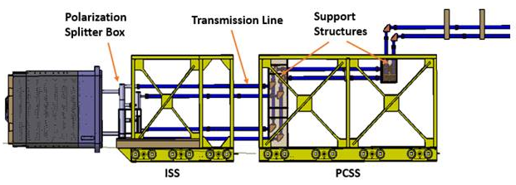

1. (b)

Figure 1: (a) showing the port plug and Ex-vessel TL including Polarization Splitter Unit, in the ISS and PCSS, (b) showing the gas compliant seal, aperture (D-point) and ex-vessel TL (Polarization Splitter Unit)

The PSU consists of two Gaussian beam telescopes which consists of three off-axis ellipsoidal mirrors, one flat mirror, and a wire grid polarizer as shown in Figure 2.

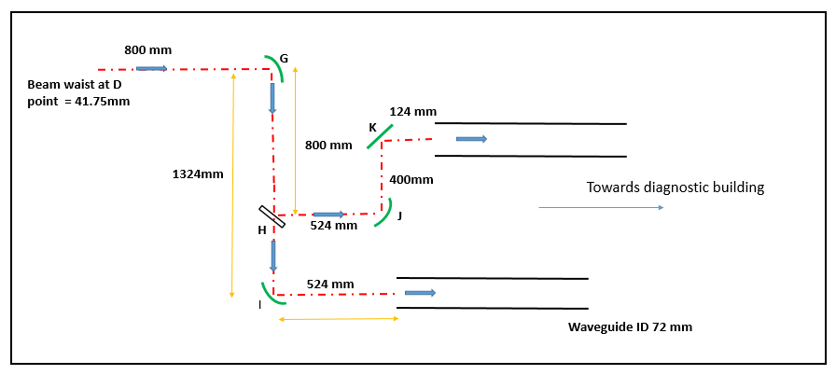

Figure 2: Optical layout of the Polarization Splitter Unit

With its high electron temperatures and harsh environment, ITER presents various challenges for the diagnostic system. One of the most insidious is the misalignment between the in-vessel front-end optics and the ex-vessel transmission line which is caused by vibration of the vacuum vessel due to plasma phenomena including vertical displacement events. Also, during operational phase @1000C and baking phase @2400C, there is relative displacement between component on Port plug back flange and interfacing components at D point [2]. Since the electron temperature is inferred from the intensity of the ECE, misalignment may lead to poor accuracy in this critical measurement. These displacements are expected to be ~ 15 mm in vertical (z) and horizontal (x) directions, and ~ 5 mm in the toroidal (y) direction. It is important to minimize the effect of these displacements, so that the system maintains alignment during operation, and reliable temperature information is obtained. An assessment of coupling loss is done for the operational phase, considering above displacement values. Here, the displacements in the operational phase will affect the ECE measurements, so only these displacements have been considered.

2 Gaussian Beam Coupling

Our objective is to first study the coupling losses due to imperfect coupling of Gaussian beams owing to port plug displacements. In this paper, different types of Gaussian beam misalignments are discussed and the power loss due to coupling of offset beams is estimated theoretically. Gaussian beam misalignments are mainly due to: (a) Axially aligned beam with offset waist (b) Offset beams (c) Tilted beams, as shown in Figure 3. [3]



1. (b) (c)

Figure 3: (a) Axially aligned beam with offset waist, (b) Offset Beams and (c) Tilted Beams

Here we have considered only the first two cases, as the third case of tilted beam is not applicable.

Axially aligned beam with offset waist: The Gaussian beam is coupled to another beam having the same waist radius, but with a nonzero axial offset.

The coupling loss due to imperfectly coupled beams is given by,

$$K_{x}=\frac{4}{{\left(x+1/x\right)}^{2}+χ^{2}x^{2}} (1)$$

Here, *x* is the ratio of waist radii, given by,

$$x=\frac{w_{0a}}{w_{0b}} (2)$$

and, *χ* is the axial waist offset given by

$$χ=\left(\frac{πω_{a}^{2}}{λ}\right)\left(\frac{1}{R_{b}}-\frac{1}{R_{a}}\right) (3)$$

*R* is the Radius of curvature of the wavefront, given by,

$R=z+\frac{{\left({πω_{0}^{2}}/λ\right)}^{2}}{z}$ (4)

Offset Beams: Two beams are offset if their axes of propagation are parallel but one is displaced relative to the other. Coupling loss due to offset is given by,

$K_{offset}=exp\left[-2{\left(\frac{x_{0}}{δ_{off}}\right)}^{2}\right]$ (5)

with, ${ δ}_{0ff}={\left[\frac{{\left(w_{0a}^{2}+w_{0b}^{2}\right)}^{2}+{\left({λΔz}/π\right)}^{2}}{w_{0a}^{2}+w_{0b}^{2}}\right]}^{2}$ (6)

where *x0* is the magnitude of offset and 𝛿𝑜𝑓𝑓 as the lateral offset distance, at which amplitude coupling is reduced by a factor of *e*.

3 Calculation of coupling losses

3.1 Axially aligned beams with offset waist

Using equation (1), the coupling loss for axially aligned beams with offset waist is calculated as *Kx* = 2.9999 x 10-4 dB. Considering the number of times the Gaussian beam couples inside the PSU as 3, the above value is then multiplied by a factor of 3, which gives *Kxtot* = 0.0009 dB.

3.2 Offset beams

Using equation (5), the coupling loss for offset beams is calculated for the expected vertical displacement of 15 mm, giving *Koffset*= 0.43 dB, for f = 115 GHz. This is then multiplied by a factor of 3, which gives *Koffsettot*= 1.29 dB. The coupling loss is calculated for the desired frequency range from 110 GHz to 170 GHz, which is the intended range for measurements, and is given in Table 1.

Table 1. Theoretical Coupling loss for Offset beams

|  |  |
| --- | --- |
| Frequency (GHz) | Koffset (dB) |
| 110 | 1.27 |
| 115 | 1.29 |
| 120 | 1.32 |
| 125 | 1.34 |
| 130 | 1.36 |
| 135 | 1.38 |
| 140 | 1.40 |
| 145 | 1.41 |
| 150 | 1.43 |
| 155 | 1.44 |
| 160 | 1.46 |
| 165 | 1.47 |
| 170 | 1.48 |

From above calculations, it can be seen that the coupling loss is maximum for vertical displacements (case b), and is negligible for radial displacements (case a). Toroidal displacement is negligibly small, and is not significant contributor to the coupling losses.

In order to validate the theoretical values, measurements are done to determine the loss due to vertical displacements.

4 Measurement of coupling loss

An experimental mock-up is done to study coupling losses due to vertical displacements, using a prototype polarization splitter unit (PSU). The experimental set-up consists of a D-band source and detector, PSU and a set of corrugated horn antennas for coupling of radiation with the PSU, for input (with source) and output (with detector) gaussian beams, as shown in Figure 4.

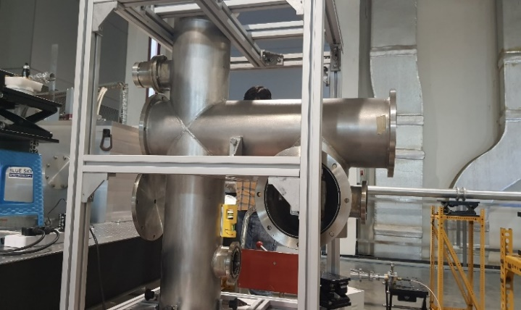 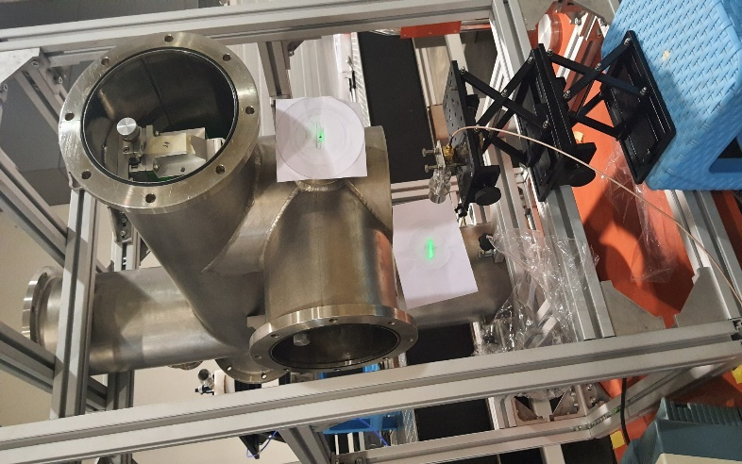

Figure 4: Experimental set-up for measurement of coupling loss

**Detector**

**PSU and support structure**

**Source**

Figure 5: Well defined laser spot at both the output ports of PSU after alignment is done

First, the mirrors inside the PSU are aligned using a diode laser as shown in Figure 5, in order to ensure proper alignment. After alignment is completed, output power is measured at Port 2 (lower port) of the PSU. Experiments are conducted for normal position, when the input beam is perfectly aligned with the PSU, and offset position, when the input beam is 15 mm offset. The ratio of output power measured for normal and offset position gives the coupling loss.

A comparison of theoretical and experimental values for coupling loss is shown in Figure 6. It can be seen from the figure that the experimental and theoretical values match reasonably well. Figure 7 shows the variation of transmission with normalized offset for different frequencies. It is observed that the transmission decreases with increasing value of normalized offset as expected.

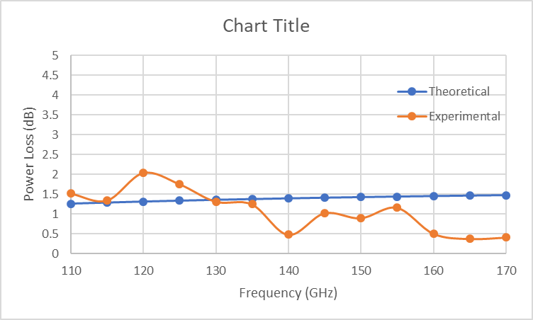

Figure 6: Comparison of theoretical and experimental values for coupling loss

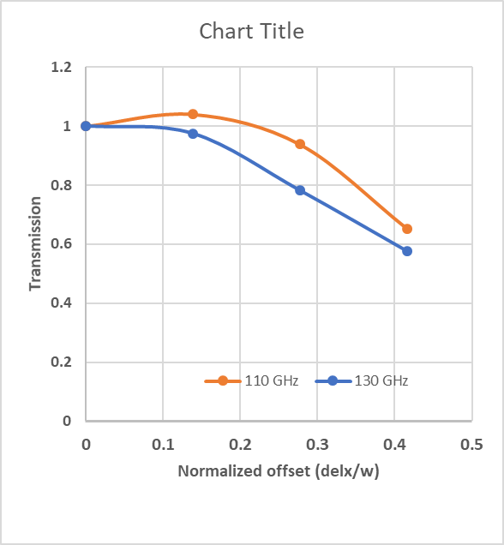

Figure 7: Transmission vs. normalized offset

5 Summary

It is observed from theoretical and experimental results that coupling loss is high for vertical displacements, with maximum loss ~2 dB at 120 GHz. Based on these assessments, there is a need to offset the displacement against the requirements mentioned above.

During Operation- In order to compensate this displacement of 15 mm in the vertical direction, the PSU will be assembled 15 mm offset (vertically upwards) with the compliant gas seal, during assembly phase at ambient temperature (room temperature). Consequently, at operation temperature @1000C, the front-end optics shall automatically get aligned with the PSU. The deviation expected is ±2 mm which can be addressed by oversized mirrors inside the PSU. However, provision will be made for one-time adjustment after getting the actual window axis position for 1000C.

During Calibration- It is proposed to perform calibration during Restart/Integrated Commissioning, when the machine shall be at operation temperature @ 1000C (without plasma). The calibration may be performed during short term maintenance phase when the machine will be at operation temperature. The situations will be identical to that in the operational phase (with plasma) and the front-end optics shall remain aligned with the polarization splitter unit. Under these conditions, calibration can be performed reliably and an accurate calibration coefficient can be obtained which can be further used to obtain plasma electron temperature.

Although it seems like at present stage the passive alignment is feasible, to account for other factors related to the port integration and environment, as a matter of the risk mitigation and ALARA, parallel work on alignment mechanism and dedicated tests on the passive alignment are planned and the decision will be made for the Final Design Review.

6 Acknowledgements

*Work of WLR and JPZ supported by the U.S. DOE under Contract No. DE-AC02-09CH11466 with Princeton University. All U.S. activities are managed by the U.S. ITER Project Office, hosted by Oak Ridge National Laboratory with partner labs Princeton Plasma Physics Laboratory and Savannah River National Laboratory. The project is being accomplished through a collaboration of DOE Laboratories, universities and industry. The views and opinions expressed herein do not necessarily reflect those of the ITER Organization.*

7 References

1. Taylor et al, EPJ Web of Conferences 147, 02003 (2017)

2. Thermal relative displacements of the ITER Vacuum Vessel Port Flanges & Connecting Ducts (VV PHTS temperature effect) IDM UID L9VRZK

3. Goldsmith P F, Quasioptical Systems: Gaussian Beam Quasioptical Propagation and Applications (IEEE Press Series on RF and Microwave Technology), 1998