Gyrotron anode voltage control in EAST ECRH system
Weiye Xu¹, Handong Xu¹, Jian Zhang¹, Fei Guo¹, and Haozhang Sun¹
¹Institute of Plasma Physics Chinese Academy of Sciences, 350 Shushanhu Rd., Hefei 230031, China
Abstract. There are four diode-type gyrotrons that are used in the EAST ECRH system now. The anode is one of the main components of the gyrotron. We can control the output power of the gyrotron by changing the anode voltage. An anode voltage control system for ASIPP anode power supplies was developed based on the ethernet CompactDAQ chassis NI-cDAQ-9185. The anode voltage can be controlled up to 30 kV, and the maximum current is 100 mA. The maximum modulation frequency is 5 kHz at a 50% duty cycle.

- Introduction
There are now four diode-type [1] gyrotrons [2] used in the EAST ECRH system [3]. According to the latest naming rules of the gyrotrons in EAST, the #1, #3, and #4 gyrotrons are from GYCOM [4], and the #2 gyrotron is from CPI. The output frequency of the #1, #2, and #3 gyrotrons is 140GHz. The output frequency of the #4 gyrotron is 105GHz or 140GHz [5]. A separate anode power supply is required for each gyrotron. The magnitude of the anode voltage affects the microwave power output by the gyrotron, as well as the electric-wave conversion efficiency.
The anode power supplies for #1 and #4 gyrotrons are from GYCOM. The parameters of the anode power supply are shown in Table 1. The range of output voltage is 5-35 kV. The resolution of the output voltage is 10 V. The maximum output current is 100 mA. The maximum pulse repetition frequency is 0.1 Hz. The pulse duration is between 10 ms and 1000 s. The remote control of the GYCOM anode power supply is realized via RS-485.
The anode power supplies for #2 and #3 gyrotrons were developed in ASIPP. A new anode power supply with 5kHz modulation capability was also developed in ASIPP [6]. The maximum modulation frequency is 5 kHz at a 50% duty cycle. The parameters of the ASIPP anode power supply are shown in Table 2. The maximum anode voltage is 30 kV, and the maximum current is 100 mA. We have developed the anode voltage control system for #2 and #4 gyrotrons based on the ethernet CompactDAQ chassis NI-cDAQ-9185.

Table 1. The parameters of the GYCOM anode power supply for #1 gyrotron and #4 gyrotron.
Input Voltage | 380V ±10% (Three-phase)
Input Frequency | 50~60Hz ±2%
Work | Pulse
Output Voltage | 5~35 kV
Output Voltage Resolution | 10 V
Maximum Output Voltage | 35 kV
Maximum Output Current | 0.1 A
Threshold Current | 0.2 A
Rising Edge of Output Voltage | <10 ms
Falling Edge of Output Voltage | <10 μs
Pulse Length | 0.01s~1000s
Minimum Interval Between Two Pulses | 2s
Maximum Pulse Repetition Rate | 0.1 Hz

Table 2. The parameters of the ASIPP anode power supply for #2 gyrotron and #3 gyrotron.
Input Voltage | 220VAC
Input Frequency | 50Hz
Output Voltage | ≤30kVDC
Output Current | ≤100mA
Ripple | ≤0.5%
Rsing Edge of Output Voltage | ≤10μs
Falling Edge of Output Voltage | ≤10μs
Pluse Length | 0~1000s

- GYCOM anode power control
The GYCOM anode power supply can be controlled through serial communication. The high-voltage power supply is equipped with an RS485 interface, which needs to be connected to the switch using the RS485-TCP conversion module, and finally realizes the communication with the host computer. The network architecture of GYCOM anode power control is shown in Fig. 1. When communicating, it is necessary to write the command message that the power supply can recognize into the serial port, the power supply responds and outputs the required voltage and current. When the power supply is turned off, the new value will not be saved. The format of the communication protocol message is shown in Fig. 2. The control program is written based on Labview [7], which can realize functions such as voltage setting and threshold setting.
The device number of the voltage controller is N=1, and the device number of the current controller is N=2. The length in bytes refers to the byte length of the command code, parameter, and check code. The parameter is a hexadecimal string (with low byte first and high byte last) that converts the voltage and current values from decimal floating-point numbers. The check code is a character string obtained by performing Cyclic Redundancy Check (CRC) on the device number, byte length, command code, and parameters and inverting them. The GYCOM anode power supply can set the output voltage value, but it cannot be adjusted in real-time. The host computer control interface of GYCOM anode power supply is shown in Fig. 3. We have tested the anode voltage and the test results for the #1 anode power supply are shown in Table 3.

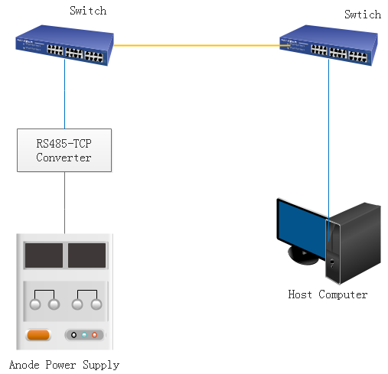
Fig. 1. The architecture of GYCOM anode power control.

Fig. 2. Communication protocol message format for the GYCOM anode power supply.

Table 3. Comparison of reference voltage setting value, read value, and the actual output value of #1 anode power supply.
Reference voltage setting value (kV) | Reference voltage read value (kV) | Actual output value (kV)
20 | 19.961 | 19.97
21 | 20.968 | 20.96
22 | 21.966 | 21.96

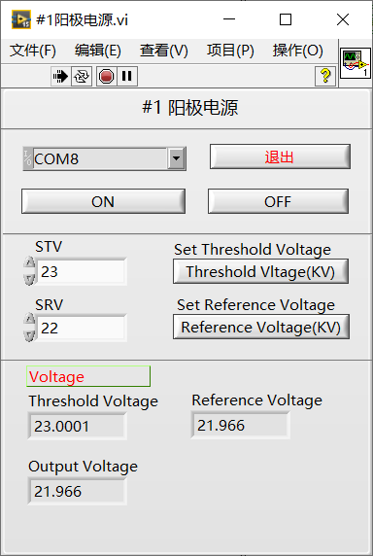
Fig. 3. The host computer control interface of GYCOM anode power supply.
- ASIPP anode power control
Two 30kV/100mA high voltage anode power supplies for #2 and #3 gyrotrons have been developed in ASIPP. In order to realize the real-time control of the anode voltage of the gyrotron, a new anode power supply with 5 kHz modulation capability has also been developed in ASIPP. It will be used for the next gyrotron in ASIPP. The power supply structure can be divided into five parts, rectifier, GTR (giant thyristor) linear compensator, inverter, high-frequency transformer and switch power supply (SPS) [6].

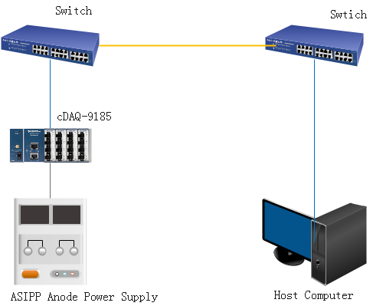
Fig. 4. The architecture of ASIPP anode power control.

We have developed the anode voltage control system for #2 and #3 gyrotrons based on the ethernet CompactDAQ chassis NI-cDAQ-9185. This anode voltage control system can also be used for the new anode power supply with 5 kHz modulation capability. The architecture of ASIPP anode power control is shown in Fig. 4. The cDAQ-9185 is used to provide a reference voltage to the anode high voltage power supply. The cDAQ-9185 communicates with the host computer through Ethernet.
The control program interface is shown in Fig. 5 and Fig. 6. We developed two control modes, one is the DC mode, and the other is the modulation mode. In the modulation mode, in addition to the modulation output, we can also control the anode power supply to output other waveforms such as sine wave, triangle wave, etc.

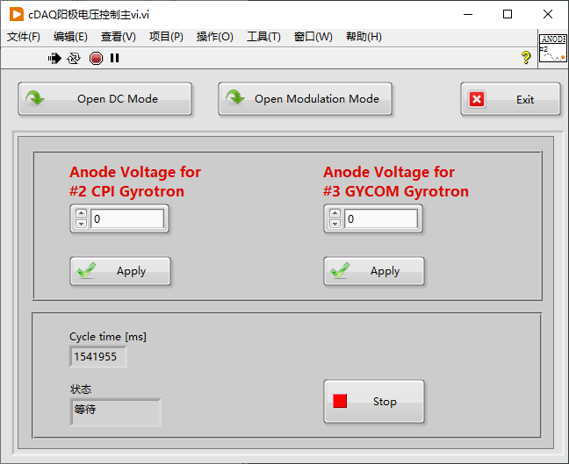
Fig. 5. The host computer control interface (DC mode) of ASIPP anode power supply.

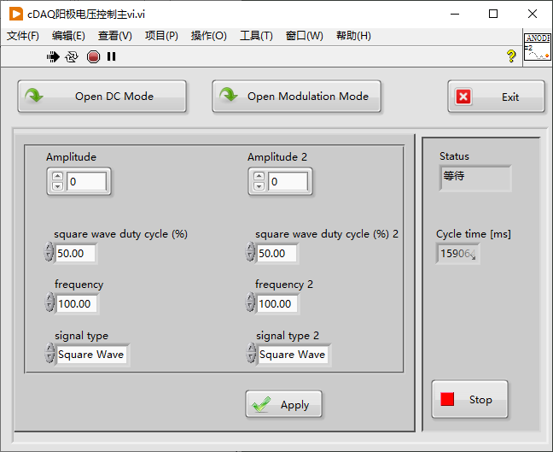
Fig. 6. The host computer control interface (modulation mode) of the ASIPP anode power supply.

The new anode power supply with 5 kHz modulation capability has been tested. Fig. 7 shows the modulation output waveform. The modulation frequency is 5 kHz, the duty ratio is 50 %, and the modulation depth is 100 %.
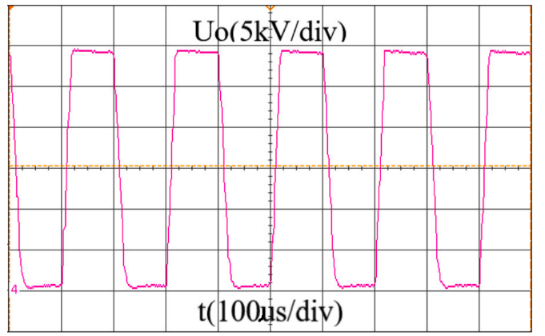
Fig. 7. The modulation output waveform of the ASIPP anode power.
- Effect of anode voltage on gyrotron output RF power
  - Variation of gyrotron output power with anode voltage when the cathode voltage is constant
The anode voltage is an important parameter that affects the gyrotron output power [8]. We have tested the corresponding change in gyrotron output power [9] by controlling the anode voltage.
The changes of the #1 gyrotron output power with the anode voltage (here refers to the voltage of the anode relative to the ground) are shown in Fig. 8 and Fig. 9. It can be seen that as the anode voltage increases, the dummy load power increases, the collector power decreases, and the efficiency improves.
Increasing the anode voltage will have the same effect as increasing the cathode voltage, the electron injection velocity will increase, the energy will increase, and the Larmor radius will increase. Compared with only increasing the cathode voltage, when the anode voltage is increased, the voltage difference between the anode and the collector (that is, the deceleration voltage) becomes larger, so that the drift speed of the electrons in the interaction area is reduced, and the electrons can be in the interaction area for a longer time, the efficiency increase is more obvious. However, the anode voltage should not be too large, because an excessively large anode voltage leads to an excessively large Larmor radius, which may not satisfy the interaction conditions, resulting in a decrease in efficiency [10].

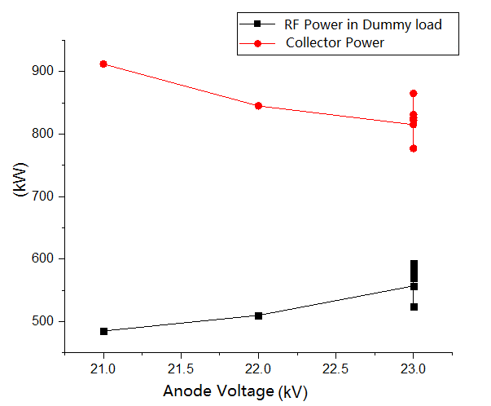
Fig. 8. Changes in the output power of the gyrotron when the magnetic field current, filament primary voltage, filament primary current, and cathode voltage are 50.55A, 39.7V, 34.7A, and -44kV, respectively.

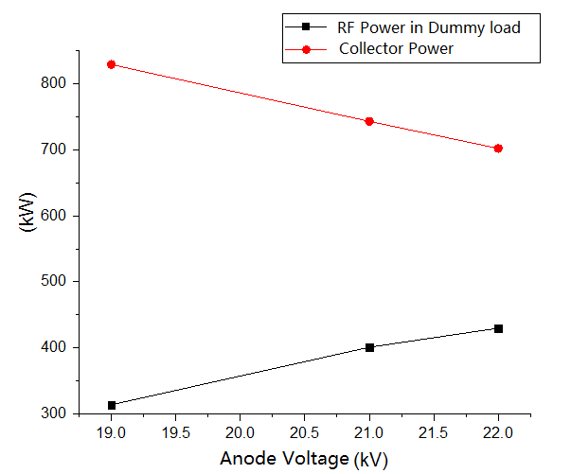
Fig. 9. Changes in the output power of the gyrotron when the magnetic field current, filament primary voltage, filament primary current, and cathode voltage are 50.55A, 39.1V, 34.4A, and -42kV, respectively.

  - Variation of gyrotron output power with cathode voltage when beam voltage is constant
When the beam voltage (the sum of the absolute value of the anode voltage and the cathode voltage) is constant, as the absolute value of the cathode voltage increases and the anode voltage decreases, the dummy load power is almost unchanged, the collector power increases, and the efficiency becomes lower, see Fig. 10 and Fig. 11.
Since the beam voltage does not increase, the electron injection velocity does not change and the Larmor radius does not change, but due to the drop in the anode voltage, the voltage difference between the anode and the collector (that is, the deceleration voltage) decreases, so that the drift speed of electrons in the interaction region increases, and the time for electrons to stay in the interaction region becomes shorter, resulting in lower efficiency.

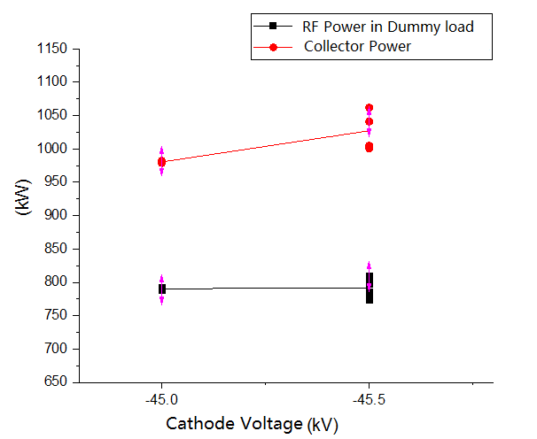
Fig. 10. Changes in the output power of the gyrotron when the magnetic field current, filament primary voltage, filament primary current, and beam voltage are 50.4A, 40.9V, 35.28A, and 68.5kV, respectively.

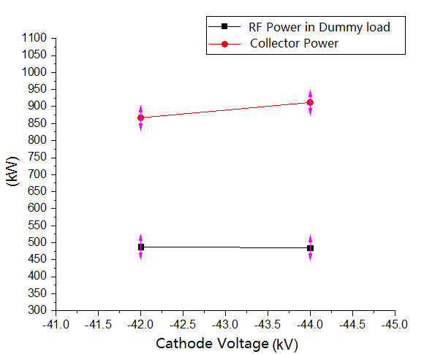
Fig. 11. Changes in the output power of the gyrotron when the magnetic field current, filament primary voltage, filament primary current, and beam voltage are 50.55A, 39.7V, 34.7A, and 65kV, respectively.

- Conclusions
Four diode-type gyrotrons are now used in the EAST ECRH system. We can control the RF output power of the gyrotron by changing the anode voltage. The control system of the GYCOM anode voltage was developed based on RS485 communication. The control system of the ASIPP anode voltage was developed based on the ethernet CompactDAQ chassis NI-cDAQ-9185. The control program was developed based on Labview. The ASIPP anode voltage can be controlled up to 30 kV, and the maximum current is 100 mA. A new anode power supply with 5 kHz modulation capability has also been developed in ASIPP. It will be used for the next gyrotron in ASIPP. Using anode voltage control, we experimentally tested the relationship between the output power of the gyrotron and the anode voltage. The test results can be reasonably explained by theory.

Acknowledgements
This work was supported in part by the National Key R&D Program of China under Grant No. 2017YFE0300401, the HFIPS Director’ s Fund under Grant No. YZJJ2020QN10.

References
¹ I. Pagonakis, S. Alberti, K. Avramidis, F. Legrand, G. Gantenbein, J. Genoud, J.-P. Hogge, S. Illy, Z. Ioannidis, P. Kalaria, B. Piosczyk, S. Ruess, T. Ruess, T. Rzesnicki, M.-Q. Tran, T.-M. Tran†, M. Thumm, I. Vomvoridis, and J. Jelonnek, EPJ Web Conf. 203, 04011 (2019).
² G. S. Nusinovich, M. K. A. Thumm, and M. I. Petelin, J Infrared Millim Te 35 (4), 325 (2014).
³ H. Xu, X. Wang, J. Zhang, F. Liu, Y. Huang, J. Shan, W. Xu, M. Li, J. Lohr, Y. A. Gorelov, J. P. Anderson, Y. Zhang, D. Wu, H. Hu, Y. Yang, J. Feng, Y. Tang, B. Li, W. Ma, Z. Wu, J. Wang, L. Zhang, F. Guo, H. Sun, X. Yan, and E. Team, presented at the 20th Joint Workshop on Electron Cyclotron Emission and Electron Cyclotron Resonance Heating, 2019 (unpublished).
⁴ A. G. Litvak, G. G. Denisov, and M. Y. Glyavin, IEEE Journal of Microwaves 1 (1), 260 (2021).
⁵ H. Xu, W. Xu, D. Wu, M. Li, X. Wang, L. Zhang, J. Lohr, J. Doane, J. P. Anderson, Y. A. Gorelov, J. Wang, Y. Hou, W. He, and T. Zhang, Fusion Eng Des 164, 112222 (2021).
⁶ J. Zhang, Z. Gao, H. Sun, Y. Zhou, J. Wang, and Y. Huang, Fusion Eng Des 153, 111479 (2020).
⁷ W. Xu, H. Xu, F. Liu, F. Hou, and Z. Wu, Fusion Eng Des 113, 119 (2016).
⁸ W. Xu, H. Xu, F. Liu, X. Wang, Y. Yang, and J. Zhang, Ieee T Plasma Sci 47 (12), 5251 (2019).
⁹ W. Xu, H. Xu, F. Liu, J. Wang, X. Wang, and Y. Hou, Plasma Science and Technology 19 (10), 105602 (2017).
¹⁰ V. A. Flyagin and G. S. Nusinovich, P Ieee 76 (6), 644 (1988).

Corresponding author: xuweiye@ipp.cas.cn
Corresponding author: xhd@ipp.cas.cn

