The ECRH-Power Upgrade at the Wendelstein 7-X Stellarator
H. P. Laqua¹, K. A. Avramidis², H. Braune¹, I. Chelis³, G. Gantenbein², S. Illy², Z. Ioannidis², J. Jelonnek², J. Jin², L. Krier², C.Lechte³, A. Leggieri⁴, F. Legrand⁴, S. Marsen¹, D. Moseev¹, H. Oosterbeek¹, T. Rzesnicki², T. Ruess², T. Stange¹, M. Thumm², I. Tigelis⁵, R. C. Wolf¹ and the W7-X team⁶

¹ Max-Planck-Institute for Plasma Physics, Greifswald, D-17491, Germany
² IHM, Karlsruhe Institute of Technology (KIT), Karlsruhe, D-76131, Germany
³ IGVP, Stuttgart University, D-70569 Stuttgart, Germany
⁴ Microwave & Imaging Sub-Systems, THALES, Vélizy-Villacoublay, F-78141, France
⁵ Department of Physics National and Kapodistrian University, Athens, GR-15784, Greece
⁶ The W7-X team is the list of authors in Thomas Sunn Pedersen et al 2022 Nucl. Fusion 62 042022

Abstract. The existing ECRH system at W7-X consists of 10 gyrotrons, with output power levels ranging from 0.6 MW up to 1.0 MW each at a frequency of 140 GHz, quasi-optical transmission lines and microwave launchers at the plasma vessel. Compared to other large fusion experiments, W7-X has a relatively low power-to-volume ratio. However high heating power is particularly necessary for achieving high plasma beta values, where the improved confinement of fast ions, one of the optimization criteria of W7-X, can be examined. It is therefore necessary to expand the ECRH systems in several consecutive steps. It is planned to increase the number of gyrotron positions from 10 to 12 and at the same time to evolve the gyrotron output power in several development steps from 1 MW to nominal 1.5 MW and, finally, up to 2 MW. At the same time, the transmission lines will also be upgraded for 2 MW operation. A special effort is also made to improve the reliability of the system by the fast control system,

Introduction
The ECRH system for stellarator Wendelstein7-X (W7-X) had been designed about 22 years ago [1]. Nevertheless, it has reliably fulfilled its tasks during the first experimental campaigns. After the successful results of the past campaigns [2],[3], the need for a modernisation and power upgrade has arisen, resulting in the strategy for the performance upgrade presented here.

Motivation
The existing 140 GHz ECRH system at W7-X consists of 10 gyrotrons with output power levels ranging from 0.6 MW up to 1.02 MW each, quasi-optical transmission lines and microwave launchers at the plasma vessel. Up to 7.5 MW with a transmission efficiency of 94% were delivered to the plasma. Compared to other large fusion experiments, W7-X has a relatively low power-to-volume ratio. However high heating power is particularly necessary for achieving high plasma beta values, where the improved confinement of fast ions, one of the optimization criteria of W7-X, can be examined. In addition, with higher heating power, one expects the achievement of improved confinement regimes, such as the H-mode.
For the further experimental campaigns, two different operational scenarios are planned for achieving the scientific goals of W7-X.
In the long-pulse scenario, plasma operation for up to 30 minutes with reactor-relevant power fluxes of up to 10 MW/m² on the plasma-facing components is to be demonstrated. To achieve this, ECRH with an absorbed power of 10 MW is required. For this purpose, two additional gyrotron positions will be equipped and fitted with 2 gyrotrons of the 1.5 MW power class.
In the high beta scenario, plasma confinement at reactor-relevant pressures will be demonstrated. For this, however, plasma heating powers of 20-30 MW are required, which can be achieved together with the NBI for plasma discharge length of up to 10 s. For this an ECRH expansion up to 18 MW is envisaged. Because of the more favourable scaling properties for the normalised plasma pressure β, a lowering of the magnetic field to 1.7 T and the operation of the ECRH at the third harmonic X-mode (X3) is also planned.

General strategy
The strategy for ECRH expansion is based on previous experience with the ECRH systems at W7-X and other fusion plants. The main findings from this will be highlighted below.

- The construction of non-modified series gyrotrons over many years prevents progress in gyrotron technology. At the end of a long delivery process, the last series gyrotrons are already outdated. This is especially the case when a number of gyrotrons requires a delivery time of 5-10 years. In the past neither our gyrotron producer nor the host team could deliver, install, test and commission more than 1 gyrotron per year.
- The ECRH system must be considered as a whole. The weakest components determine the performance. The individual components must be matched to each other as optimally as possible. This already applies to the building of the ECRH installation and the access space to the experiment. The effort and cost of ECRH performance is far greater than the cost of providing adequate installation space, so economizing on installation space does not make sense.
- All components should be equipped with sufficient safety margin and reserves for a later power expansion since there must be technology progress expected.
- The control system in a long-pulse or continuous wave experiment is fundamentally different from that in a pulsed experiment. Here, the control system must analyse the interlock signal in real time and, if necessary, enable a quick restart. It is also important to categorise the interlocks and carry out appropriate reactions, such as stop or warning messages.
- The complexity of the system must be minimized. Every unnecessary actuator, sensor, cooling circuit reduces the reliability of the system. For this reason, an existing system should always be checked for the possibility of simplifying or omitting components, sensors, etc. These findings can then be implemented when planning the expansion.
Gyrotrons
The strategy for increasing ECRH power is based on utilising the existing infrastructure for optional upgrades, which has been already planned in the initial installation. First of all, the two reserve positions F1 and F5 will be equipped with two new 140 GHz CW gyrotrons of the 1.5 MW class. For each position, the entire periphery, such as water cooling and transmission lines, will of course be built, taking into account previous experience. For example, the remote control of all transmission mirrors was abandoned because it is only needed once during the adjustment phase and is then switched off. Manual adjustment is possible without any problems but needs more time. The ECRH launchers were designed from the outset to operate with 12 beams. Also, all transmission components are already designed for a power of 2 MW, although so far they could be tested up to 1 MW only. The high-voltage supply at the IPP can supply 12 gyrotron positions with 3.3 MW of electrical power each. For pulses of less than 10 s, even twice the electrical power is possible.

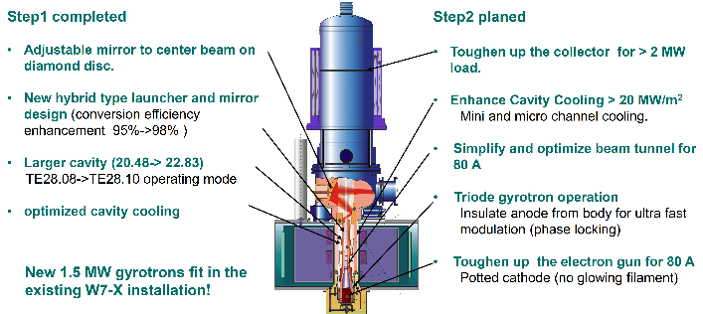
Fig. 1. Improvements in gyrotron design realised in step 1 and planned for step 2.
.
The basic strategy is first to fill the vacant positions and then to replace the outdated, weaker gyrotrons with more modern, more powerful ones. The constraint is that the new gyrotrons should be as compatible as possible with the old installation, so that the system retains a high degree of modularity and parts from one position can be used in the others. This is also extremely labour and cost efficient and reduces the development risk for new components.
Therefore, as shown in Fig.1 a new gyrotron has been developed together with KIT and Thales, which is based on the successful 1 MW W7-X design and is fully compatible with the existing system. The original TE28.08 cavity operation mode was changed to the TE28.10 mode, which increase the cavity surface by 25%, The cavity cooling was also optimised even further, which made it possible to increase the output by 50% power to 1.5 MW. Furthermore, the more than 20-year-old design of the internal mode converter was optimised, increasing the mode conversion efficiency from the gyrotron mode to the HE11 output mode from about 95% to 98%. Finally, the output coupler mirror opposite to the diamond window was improved to be externally adjustable, which should enable perfect centering of the microwave beam at the diamond window in order to minimize thermal stresses due to asymmetric loads. The new cavity and microwave optic was successfully tested in advance in an almost identical short pulse gyrotron, where the 1.5 MW operation at 45 % efficiency was demonstrated in the millisecond range [4].
This development project, which is close to completion with the delivery of the industrial gyrotron to the KIT test facility, is part of a four-stage development program for increasing the ECRH power at W7-X up to 18 MW by 2030 as shown in Fig.2. The industrial gyrotrons are to be improved step by step in permanent cooperation with KIT and Thales. In the second step, which is currently being prepared, 3 more 1.5 MW CW gyrotrons will be purchased. Their critical components, however, will be successively developed to the 2 MW power class level, so that a 2 MW prototype gyrotron can be built in the third step. If this is successful, 3 more CW gyrotrons of the 2 MW class would be ordered in a fourth step, whereby successive improvements should also be possible. In this process the risks are shared between consumers and industry. This strategy will promote European gyrotron development and ensure that the most modern gyrotrons are always available and acquired.

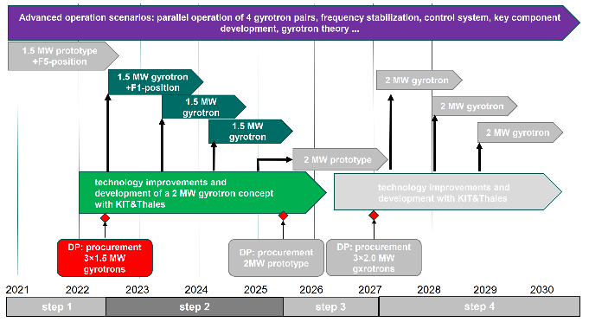

Fig. 2. Four Step Strategy for the ECRH-upgrade at W7-X. Step 1 and step 2 are already approved.

Transmission line
In line with the increase of the number of gyrotrons from 10 to 12, the transmission line must also be expanded by two more beams. However, this is only necessary for the individual beam sections. The multi-beam section is already designed for 12 beams and does not require any additional adjustment, since it was already aligned for the existing beams. .A new microwave beam only needs to be adjusted on the beam combining mirror and it is automatically imaged on the beam dividing mirror. In addition, the new mirrors were designed with the proven technology of a stainless steel base body with cooling channels on which a 2 mm thick copper layer is electroplated. The launcher in the plasma vessel was already built for 12 beams.
In addition to increasing the number of beams, their transmission capacity must also be raised to the increased beam power of 1.5 and later 2 MW. The cooling capacity of the mirrors was already designed for 2 MW beam power, but the previous experimental campaigns showed that problems due to arcing at certain points in the transmission line already occurred below 1 MW. This was particularly problematic in the summer months with high absolute humidity. The problem mainly occurs between mirror no. 13 and no. 14 in the transmission line where a tiny vertical focus exists. Its waist varies between 11 mm and 20 mm depending of the beam line
Here the electric field strength is strongest and the convection air flow is in the unfavourable direction parallel to the beam. Therefore, the design of the mirror 13/14 combination was modified in such a way that the beam waist at the focal point was enlarged. This was initially implemented for the two new beam lines, but can be also implanted in the existing beam lines if necessary. To further reduce arcing, the transmission line was equipped with a powerful air drying system that blows the pre-cooled dry air into the critical area. With the help of a corner reflector, which was installed directly in front of the diamond vacuum window on the plasma vessel, the complete transmission line could be tested with maximum power as shown in Fig. 3. The beam of the A gyrotron was transmitted to the retroreflector via the A beam line and then sent back to our long pulse microwave load via the F mirror line. This situation simulates the transmission of 2 out of 3 beams to a launcher and the transmission of the maximum gyrotrons power of 900 kW could be shown. Unfortunately, the transmission for higher powers can only be verified when such gyrotrons are available. The arrangement also allows the exact determination of the transmission losses because the beam passes through the transmission path twice. This resulted in a transmission efficiency of about 94%, which corresponds to the theoretical value and confirms previous measurements, where the retro-reflector was positioned at the end of the multi beam section [5]
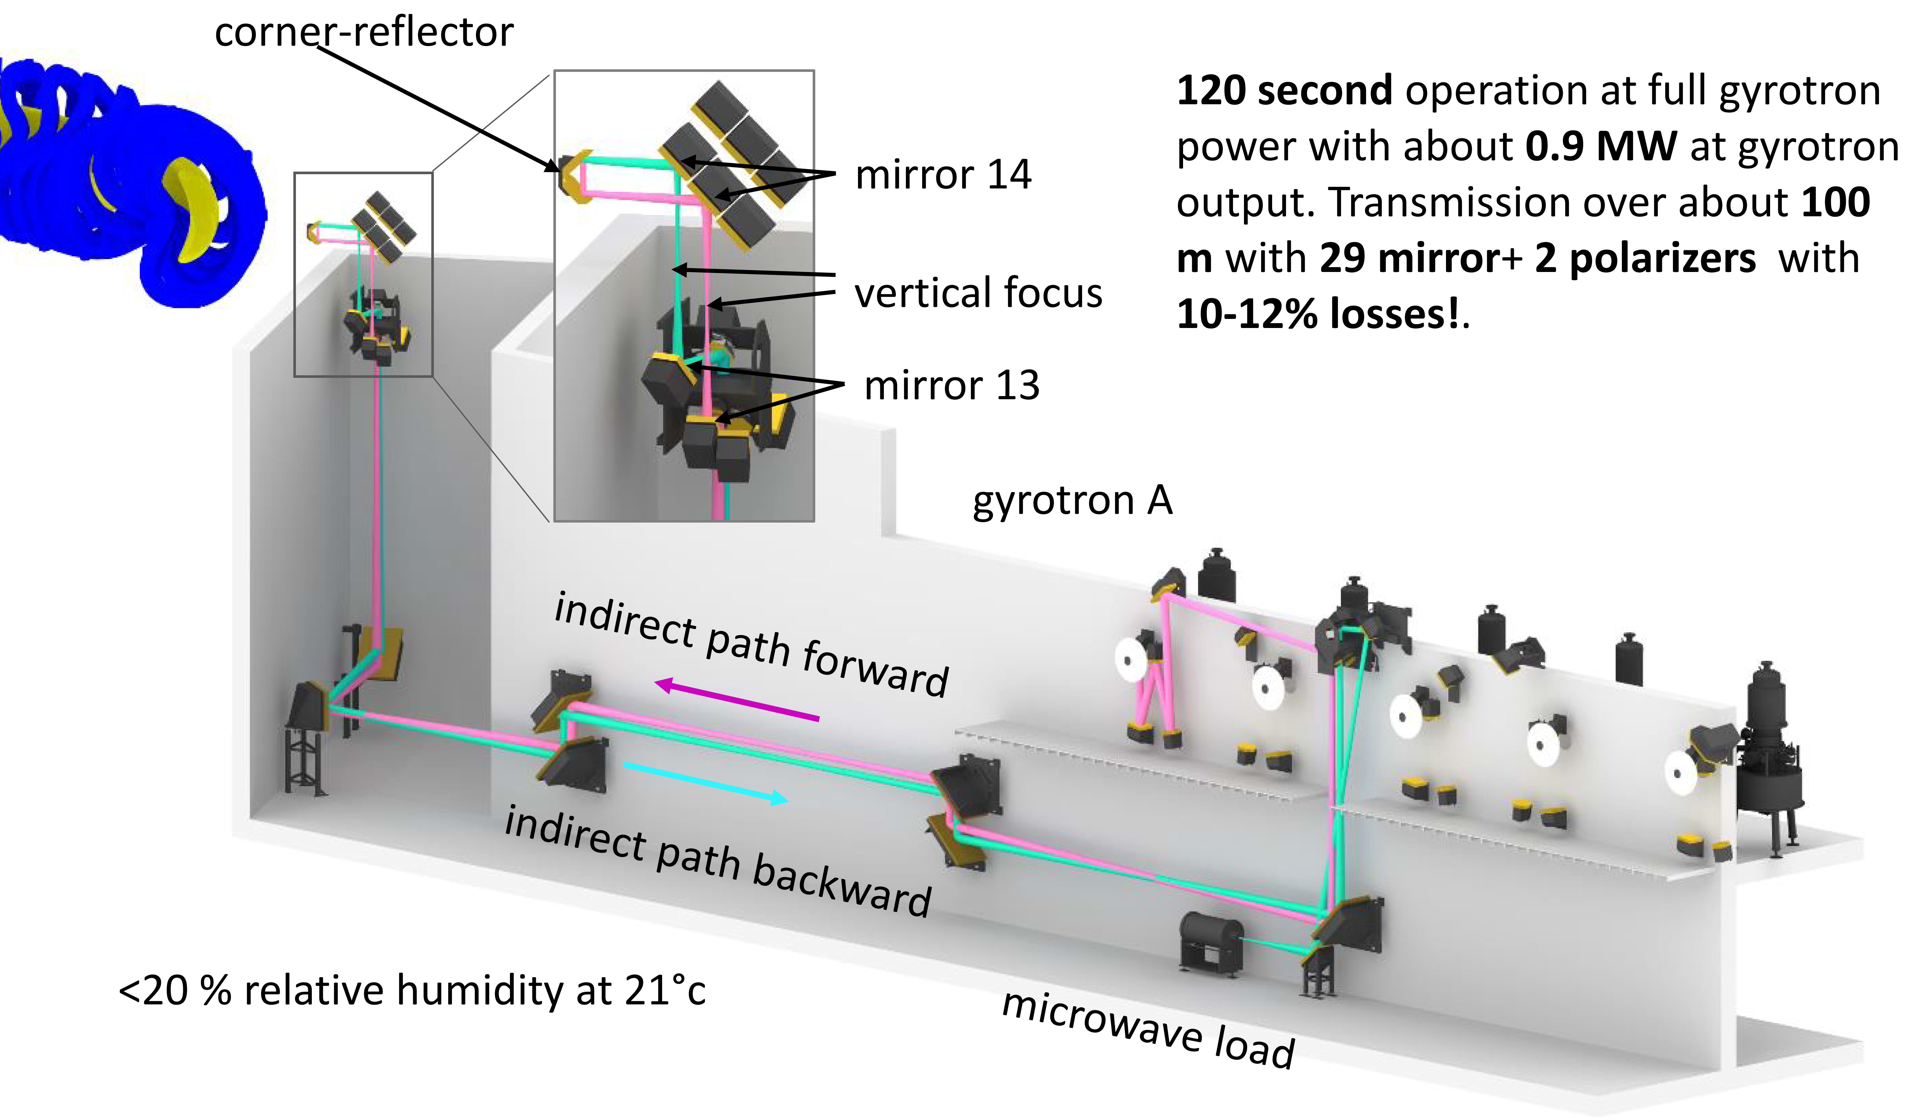
Fig.3. Sketch of the full power tests over twice the length of the transmission line with the A beam to the retro-reflector and via the F beam line back to the microwave load. The relative humidity was set below 20% at 21°c.

Control
The control system is the crucial component for a safe and reliable ECRH system. However, the requirements for safety and reliability can be contradictory. In particular, the fast interlock system must react in sub-milliseconds in the event of an error and switch off the gyrotron. In long pulse or continuous wave mode, however, it is possible to analyse the error automatically and immediately and switch the gyrotron on again if possible. An example of this is the mode recovery system shown in Fig. 4, which detects a mode loss within 0.2 ms and lowers the acceleration voltage until the operation mode settles again. Then the voltage is raised again to a value just below the original set-point. From there, the voltage is ramped up to the nominal value in a much slower ramp. In this way, the gyrotron samples its maximum power range [6].
After the operation phase OP1.2b, the interlocks that occurred were statically evaluated as shown in Fig. 5 and appropriate improvements were made. The main cause of gyrotron shutdowns was arcing in the transmission line. These should be reduced by the new air conditioning. In addition, the arc detection is currently being changed from light sensors to the much faster RF sensors. Faster detection should also allow faster restarting. Other issues are often problems with certain sensors, e.g. water flow monitoring, which often cause false alarms. Here a systematic renewal is taking place.

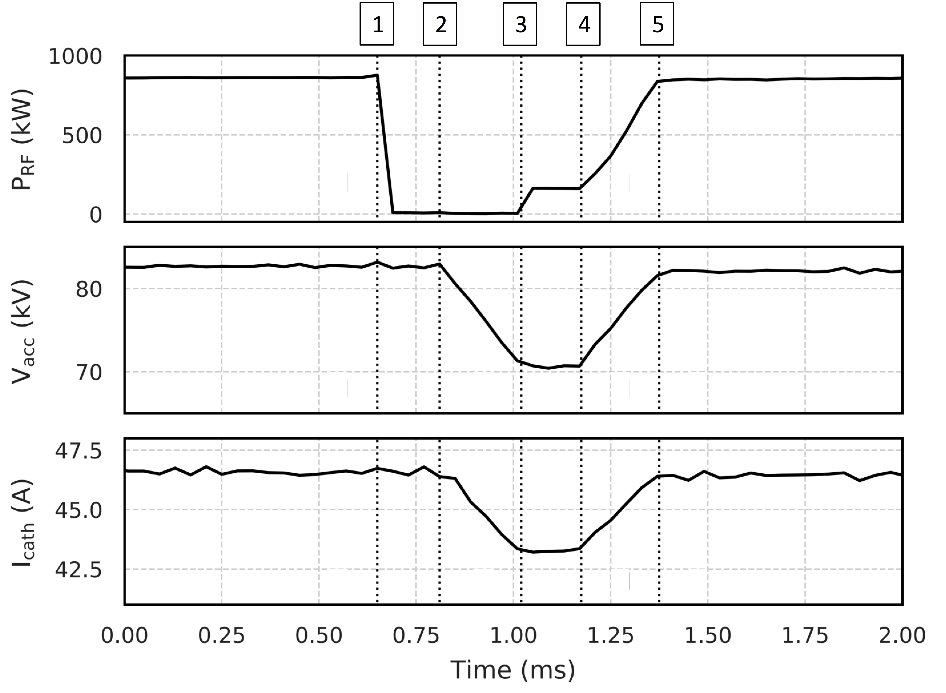
Fig. 4. Operation diagram of the mode recovery system [2]. 1) Mode loss 2) Detection of the mode loss and rapid decrease of the acceleration voltage by 10 kV. 3) Reestablishment of the gyrotron mode. 4) Rapid ramping up of the acceleration voltage to just below the nominal value. 5) Slow voltage ramp up to the nominal value.

Another future-oriented development is the external frequency stabilisation of the gyrotrons [7]. With the help of a phase lock loop (PLL), the frequency of the diode-type gyrotrons is controlled with the acceleration voltage as shown in Fig.6. This enables highly precise scattering experiments with CTS diagnostics . However, if it were also possible to lock the gyrotron in phase, completely new possibilities would open up for ECRH operation. All the gyrotrons would then emit coherently and it would be possible to merge many microwave beams into one. It would also be possible to switch the direction of the sum beam with the phase of the individual beams [8].

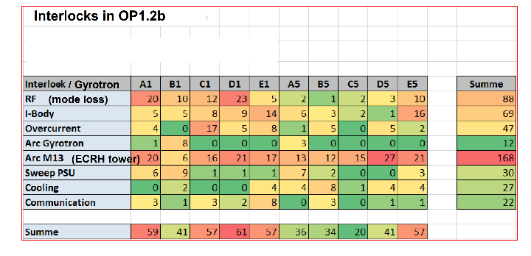
Fig. 5. List the interlocks of the individual gyrotrons that occurred in operation phase 1.2b and their causes.

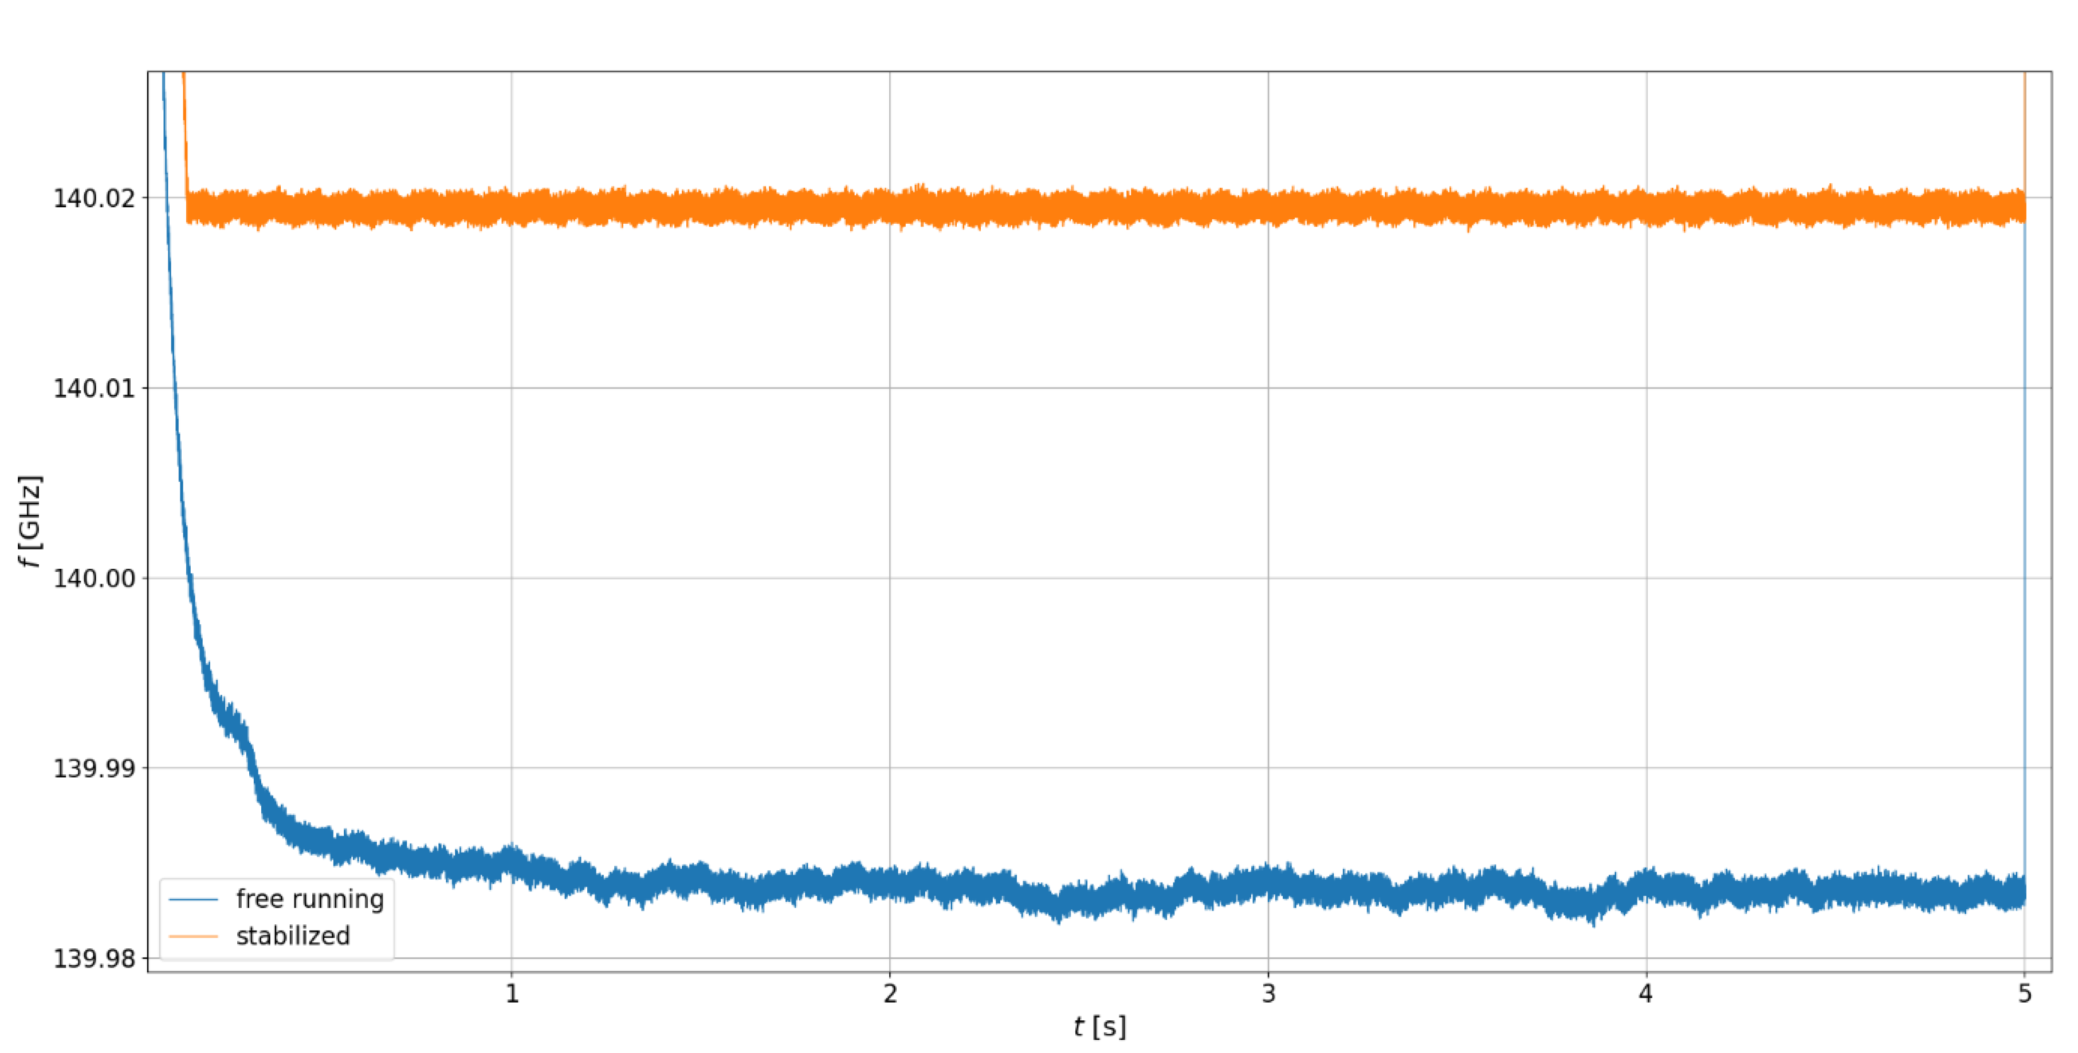
Fig. 6. Frequency as a function of time of a free running gyrotron in blue and a frequency stabilized gyrotron in orange.

Summary and conclusions
The strategy for the expansion of the ECRH system at W7-X has been presented, based on the experience gained in the construction and operation of the existing ECRH facility. The gyrotron development will be carried out in a four-step process, which guarantees a permanent improvement of the tubes. In addition, the entire ECRH facility will be optimised to meet the higher requirements for power generation and transmission. This means that in ~2030, 12 fully equipped microwave beam lines with a high level of reliability and a total output of around 18 MW (4x1MW+4x1.5MW+ 4x2MW) are foreseen.

References

- Erckmann et. al. Fusion Science & Technology, Volume 52, Number 2, August 2007, Pages 291-312
- Beidler, C.D., Smith, H.M., Alonso, A. et al., Nature 596, 221-226 (2021)
- T. Sunn Pedersen et al. 2022 Nucl. Fusion 62 042022
[4] K. A. Avramidis et al., Fusion Engineering and Design 164 (2021) 112173
[5] T. Stange, et al, EPJ Web of Conferences 157, 02008 (2017)
[6] F. Wilde et al., Fusion Engineering and Design 148 (2019) 111258
[7] L. Krier, et al., https://doi.org/10.1109/IRMMW-THz50926.2021.9566847
[8] V. Erckmann, W. Kasparek, K. van’t Kloosters, Y. Koshurinov,
S. Kubo, M. Petelin, K. Sakamoto, M. Thumm, Z. Wu: Quasi-optical components for microwave control and remote sensing. 15th IEEE International Vacuum Electronics Conference (IVEC 2014), 2014, Monterey, CA, USA, 3.3.

Acknowledge

This work has been carried out within the framework of the EUROfusion Consortium, funded by the European Union via the Euratom Research and Training Programme (Grant Agreement No 101052200 — EUROfusion). Views and opinions expressed are however those of the author(s) only and do not necessarily reflect those of the European Union or the European Commission. Neither the European Union nor the European Commission can be held responsible for them.

